FM radio receiver with digital tuning

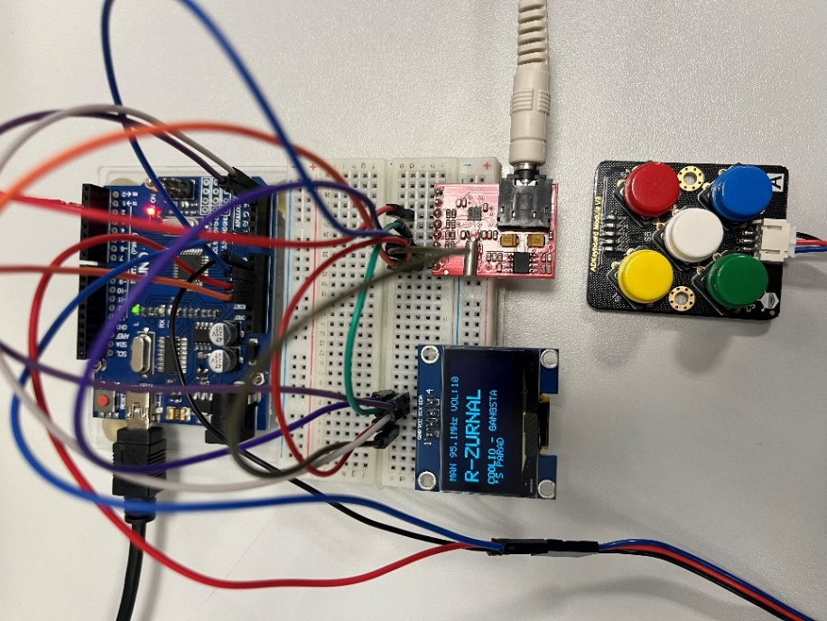
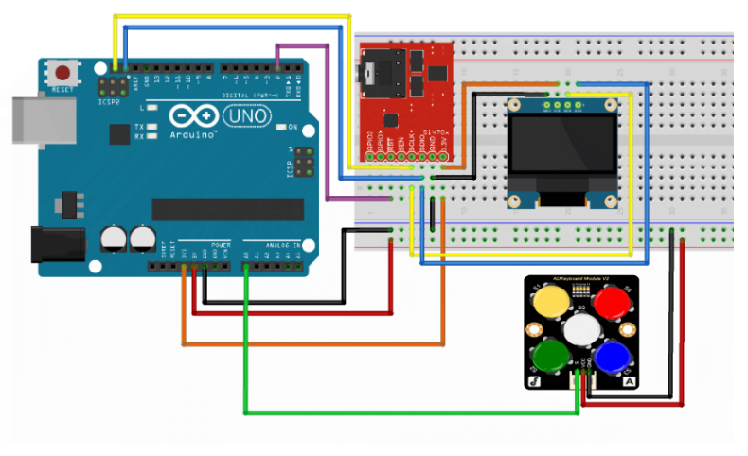
Git hub
Abstract
The main objective of this project is to implement fully functional FM radio receiver with digital tuning on ATmega328P-based Arduino Uno board. The tuner module Si4703 is controlled over the I²C bus. I²C OLED display is used for the main user interface. Basic push buttons are used for controlling the receiver. This project also features the RDS (Radio Data System) to show the station name and radio text.

Team members
- Mezera Vojtěch
- Moravec David
- Mostecký Filip
- Pavlíček Michal

Button Control
- S1 – next station / increase frequency
- S2 – previous station / decrease frequency
- S3 – volume down
- S4 – volume up
- S5 – toggle tuning mode (AUT ↔ MAN)

Radio Functions

Automatic Mode (AUT)
- Default at start
- Scans FM band, evaluates signal via si4703_getRSSI()
- Threshold: 19 (0–127); stations ≥19 saved to list
- S1/S2 cycle through list (wrap-around enabled)

Manual Mode (MAN)
- Activated by S5
- S1: +0.1 MHz, S2: –0.1 MHz

Volume
- S3: down, S4: up
- Value shown on OLED display

RDS
- Displays station text if available
- Updates dynamically
- Shows last valid text or if unavailable -----

